I. INTRODUCTION
Kinect Based Edutainment System For Autistic Children
Humaira Rana¹, Shafaq Zehra², Almas Sahar³, Saba Nazir⁴ and Dr. Hashim Raza Khan⁵
¹²³⁴⁵ Department of Electronics Engineering, NED University of Engineering and Technology,
Karachi, 75290, Pakistan
¹engr.humairarana@gmail.com,²shafaqzehra1@gmail.com,³almassahar08@gmail.com,⁴sabanazir001@gmail.com, ⁵hashim@neduet.edu.pk

Abstract: Engineering has provided solutions for complications which once seemed insurmountable and elevated the standard of living for everyone. Engineering innovation has carved new ways to enhance the capabilities of ‘differently-abled’ people. The activity designed in this project, aims to enhance the learning ability of Autistic children. During the designed activity, the child has to stand in the field of view of Kinect and perform some pre-determined hand gestures. Kinect detects the skeletal movement of the child and the data acquired by Kinect is fed into Matlab for processing. An Arduino UNO board acts as an intermediate interface between Matlab and a transmitter of RC Toy Car. Arduino UNO receives signals from Matlab which then sends signals to TX2 IC embedded on RC Car Transmitter which in turn actuates the car hence virtually Toy Car is moved by the Hand Gestures of the child and this intends to improve the Hand-Eye Coordination of the child. This project can be further enhanced by replacing Toy Car with a Humanoid Robot to imitate the movements and gestures of the child along with audio stimulus for speech therapy
Keywords: Autism, Autism Spectrum Disorder (ASD), Kinect, Matlab, Arduino UNO.

According to fact sheet, about 15% of the world’s population is estimated to live with some form of disability. Cognitive or learning disability refers to vast variety of brain related diseases that affects the mental tasks of an individual when compared to a healthy person. Learning disability in a person can be due to two reasons: inherited (by birth) or due to some injury which results in brain damage.

Autism is a complex neurodevelopmental disorder found in children resulting in improper functioning of human brain. Symptoms of the disease must be present in the early developmental period of life i.e., first two years. It is also known as Autism Spectrum Disorder (ASD) where the term spectrum defines different ranges of the disease. The spectrum varies from High Functioning Autism to Low Functioning Autism including Asperger Syndrome, Dyslexia and other such mental illness in its range. A person with an ASD mainly copes with social and communication skills. About 1 in every 150 children suffers from autism globally. Constant deficits in social communication, restrained or repetitive patterns of behavior, routines, interests, or activities, inappropriate laughing and giggling, no fear of danger, echolalia (repeating words or phrases instead of using normal language), inappropriate attachment to objects, difficulty in expressing needs, aggressive behavior, memory related problems, motor activity (balance regulation, body movements, coordination of muscles used for speaking) and control of primitive functions of the body including
breathing and heart rate are some of the symptoms observed in children suffering from Autism.

Rapid growth of robotics in today’s world has provided the great minds with loads of opportunities to work out for the treatment of patients with Autism Spectrum Disorders (ASD) with the help of a humanoid robot. Such a robot can perform human-like functions, and assists with the goal of improving social skills in individuals with ASD. An experiment was performed in school of Birmingham on Autistic children and they were taught through humanoid robots. It was concluded that since these robots are cute in looks and they show no emotions that’s why autistic children can easily engage with these robots and find them less threatening than humans. Most famous example of such robots are: NAO launched by a French company ‘Aldebaran’ and Probo launched by Vrije Universiteit Brussel (VUB) .

In this work, a low cost solution is developed to assist teachers and trainers working with autistic children to teach them a variety of skills. The system involves a toy car which follows the hand gestures of the autistic child. In the next section, hand gesture recognition using Kinect is described. It is followed by interfacing of Kinect with Matlab and how Kinect captures the joint positions of a person standing in front of it. Then a brief explanation of Matlab program is described. Afterwards control interface is explained which leads to the movement of car based on the hand gesture of child. Then the project testing and results is enlightened which is concluded along with future directions.

II. METHODOLOGY
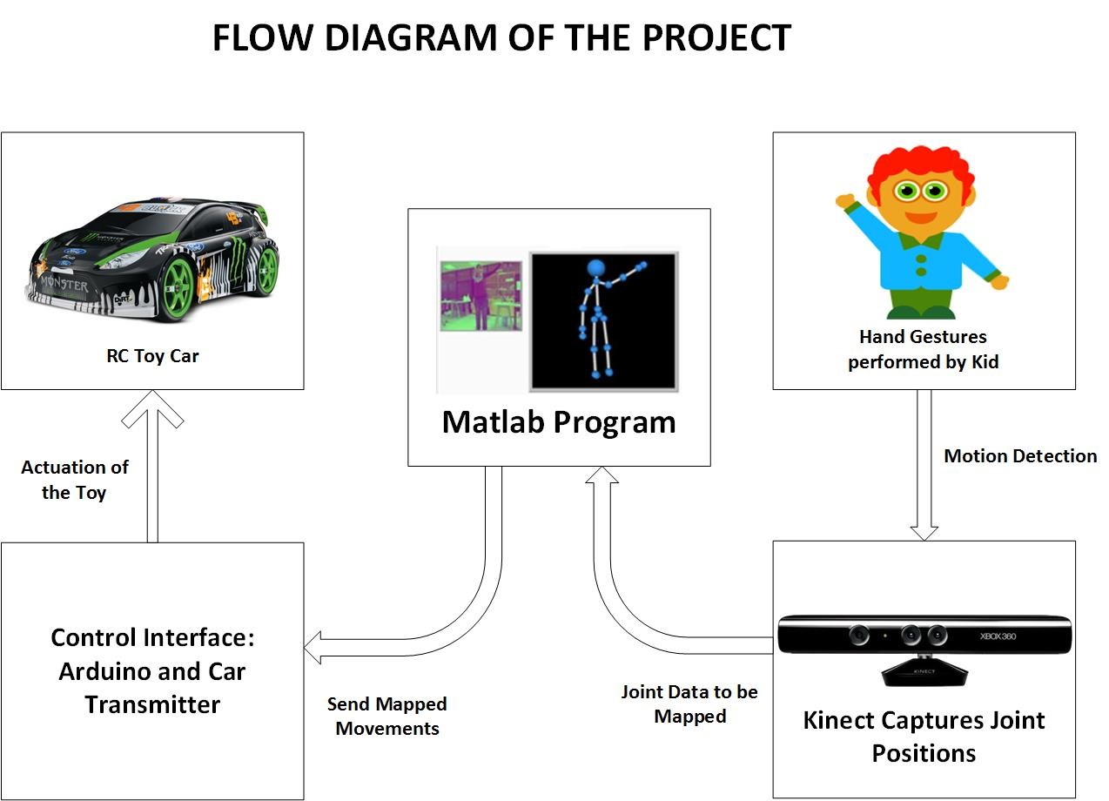
Figure 1 Flow Diagram of the Project
- Hand Gestures Performed by the Kid

Autistic children suffer with poor Hand-Eye coordination and this game is intended to help them in improving their Hand-Eye coordination. A toy car is supposed to move, based on the hand gestures of the kid. Kinect is being used as a data acquisition tool and the data acquired from Kinect would let the backend program know about the particular hand gesture performance.

To participate in the activity, a child must be in the angular field of view for both the RGB camera and Depth sensors, embedded in Kinect, which is approximately 57° horizontal and 43° vertical. Both sensors acquire data at the rate of 30 frames per second. After standing in the field of view, the kid has to perform some gestures.

We have selected the following four gestures:

1. Right hand up to move the car forward.

2. Both arms up to move the car backward.

3. Right arm down and other arm pointing towards left to turn the car left.

4. Left arm down and other arm pointing towards right to turn the car right.
- Interfacing Of Kinect With Matlab

Kinect sensor is actually designed for Xbox 360 and interfacing it with the computer was one of the challenging milestones of the project. The major obstacle was unavailability of was the main website (openni.org) that contained unstable NITE (OpenNI Compliant Middleware Binaries), these were the necessary files required for interfacing. Thus an alternate way had to be figured out. Struggling through various ways, we finally reached to a solution to interface Kinect with the laptop. Main requirements of which include:
- Laptop or PC having 1.5GHz or above processor
- Visual studio 2010 or above
- Matlab version 2013 or above
- Sensor drivers from
- OPEN NI binaries from
- KinectSDK-v1.8-0
- KinectDeveloperToolkit-v1.8.0

Next step was to interface Kinect with Matlab so as to program the data captured from the Kinect in Matlab,

- Bin folder of Matlab required following libraries
- Fil_rouge-master
- firmata-master
- gl-matrix-master
- js2-mode-master
- websocket-master
- kinect for windows runtime v1.8
- Joint Positions Captured By Kinect

Position of person (standing in front of Kinect) can be located with the help of its coordinates. A pattern of IR dots is projected from IR sensor and detected back via CMOS. Position and size of these dots will vary according to their distance from Kinect and the way it reflects light.

Now this data helps in computing depth image. Afterwards, depth image and color image are aligned to produce RGBD information. This RGBD information is sent to MATLAB in the form of matrix to take proper decisions and actuate the toy car.
- Matlab Program

MATLAB code we used in our project perform the following functionality:

First of all it will take video input for RGB and depth and continuously track the skeleton of the object. Then through MATLAB codes we synchronize both RGB and depth image. Since MATLAB is also utilized to send commands to toy car through Arduino. So we initialize a variable to start communication with Arduino.

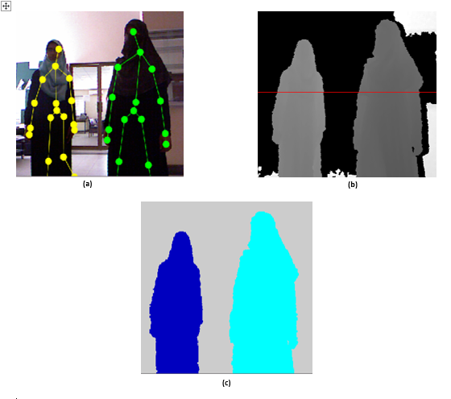
Figure 2 (a) Skeletal (b) Depth and (c) Segmented Image acquired in Matlab

The sole purpose of this code is to actuate the car that includes:
- To move the car in forward direction when child raises his right hand up, coordinates of head and coordinates of right hand are compared and decision will be taken accordingly.
- To move the car in backward direction when child keep both hands down, same procedure is followed.
- When child points towards right while keeping other hand down, we compute distance of right hand from right shoulder and if this distance is in desired range, toy car will move towards right.
- Same procedure is followed to move the car in left direction.
- Control Interface

Arduino UNO is acting as a control interface between data acquired by Kinect in MATLAB and Wireless Transmitter of the car. Arduino is selected because it can be easily integrated with MATLAB.

With MATLAB Support Package for Arduino Hardware, MATLAB can be used to interactively communicate with an Arduino board over a USB cable.

The package enables one to perform tasks such as:
- Acquire analog and digital sensor data from your Arduino board
- Control other devices with digital and PWM outputs
- Drive DC, servo, and stepper motors (also supports Adafruit Motor Shield)
- Access peripheral devices and sensors connected over I2C or SPI

Since MATLAB is high level interpreted language, results from I/O instructions can be immediately seen without compiling.

In this project, Arduino is getting instructions by MATLAB to actuate the car in proper directions.
- Movement Of The Car

Arduino is connected with the wireless transmitter of the car. TX2/RX2 ICs are key components of RC Cars and TX2 is the heart of the remote controller of the car. Arduino’s four digital I/O pins are connected with the right, left, forward and backward function pins of TX2 IC, each separately. Also transmitter’s power wire is connected to the 3.3 V pin of the Arduino and transmitter’s ground is connected to the GND of the Arduino. Between each of the Arduino's digital pin and the transmitter's function pin, a 10K Ohms resistor is placed for protection. As soon as a signal is received on the function pine of IC, it will send the corresponding signal to move the car and so car is moved based on gesture performed by kid.

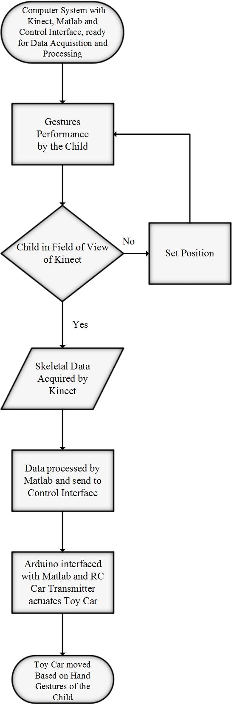
Figure 3 Flow Chart

iii. testing and results
.

The system was mainly designed to ameliorate motor activity of an Autistic child. Thus, meeting such children and observing them was one of the major parts of this research. We discovered two centers in our city named ‘Centre for Autism (CFA)’ and ‘Al-Umeed Rehabilitation Academy (AURA)’ that is rendering services to such children. We made a quick visit to explore both the places and found CFA more relevant to our subject. AURA has very few children who were suffering from Autism along with other diseases such as Cerebral Palsy (CP), while Centre for Autism is purely working for Autism. People at CFA were welcoming and arranged visits for us during their study timings. Having a few visits at CFA was highly motivating. The children over there were indifferent with our presence and their anti-social behavior was significant. Few other significant behaviors that we noticed was their irritation towards different sounds in the environment, not paying attention to what was being taught but when questioned majority gave the correct answers which was totally fascinating. It proved that there is a great potential may be more than us normal people to bring the best out of them. The teacher over there mentioned that their reading power is something that accentuates them amongst other children. They possess this great quality of remembering the words they read. Although, it is really difficult to make them know what they possess and how to utilize their potential, these children were really adorable and interesting.

After completion and testing of the designed prototype, we took it to CFA to perform the activity with the ones for whom it was designed. Results were formulated after testing the prototype with Autistic children who were present at Center for Autism, Karachi, which includes the following major points:

- Initially children were extremely attracted towards the toy car and became more excited after watching the car moving with their hands gestures.
- Children of age group (2 to 6 years) were unable to move their hands as it was required and so were assisted by their mothers who acted as a prompter.
- It was really difficult to make them pay attention towards the activity rather they were more attracted towards the toy car and the laptop screen.
- Kinect was programmed to track only one skeleton which did not allow any prompter to come in its view. Thus, one of our team mates performed in front of camera and parent assisted the child in duplicating the actions perhaps virtually performing the activity which proved to be successful.

Although we had planned to design more activities in the form of a game such as Maze game, color identifying using toy car. But these activities were inappropriate for the children of age group we met. Maze game was made in parallel to our prototype completion but was not tested with the kids.

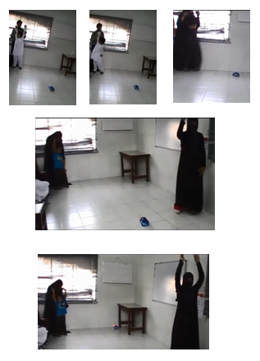
Figure 4 Testing at Centre for Autism

iv. Conclusion

A Remote Controlled toy car based edutainment system was developed which works upon the gesture of a person. It was developed mainly for children suffering from the neuro-developmental disease named Autism. By making different hand gestures the child can learn few basic actions in life and can gain the sense of directions i.e. Right, Left, Forward and Backward.

Making children of such small age group perform this activity was a difficult task which concluded that these children can take more than a year to get practiced to these movements. Although, the case will be different with the higher age group and they can learn more effectively and quickly.
- Future Directions

The augmentation in this project can be performed in one of the several ways:
- Kinect can be replaced by a normal webcam in order to reduce the cost.
- Laptop screen to be avoided by an on-board computer such as Raspberry-pi to gain more attentions of the children and make the prototype compact.
- Project should be able to track more than one skeleton.
- Toy car can be replaced by a humanoid robot.
- Educational games can be developed for Autistic as well as normal children

REFERENCES

Disability and Health, Fact Sheet No. 352, World Health Organization, December 2015isability and Health, Fact Sheet No. 352, World Health Organization, December 2015

